 | 26.9.2 Editors - Properties Editor - Modifiers Properties Tab - Grease Pencil - Generate Modifiers
Table of content
Detailed table of content 1
Grease Pencil - Generate modifiers 6
Array 6
Build 8
Dot Dash 11
Envelope 13
Length 14
Line Art 16
Mirror 21
Multiple Strokes 22
Simplify 23
Subdivide 25

Detailed table of content

Detailed table of content
Detailed table of content 1
Grease Pencil - Generate modifiers 6
Array 6
Count 7
Material Override 7
Relative Offset subpanel 7
Factor X/Y/Z 7
Constant Offset subpanel 7
Distance X/Y/Z 7
Object Offset subpanel 7
Object 7
Randomize 7
Offset 7
Rotation 7
Scale 7
Uniform Scale 7
Seed 8
Influence subpanel 8
Layer 8
Inverse Layers 8
Pass 8
Inverse Pass 8
Material 8
Invert Materials 8
Pass 8
Inverse Pass 8
Build 8
Mode 8
Sequential 9
Transition 9
Start delay 9
Frames 9
Concurrent 9
Time Alignment 9
Align Start 9
Disappear 9
Transition 9
Start delay 9
Frames 9
Additive 9
Start delay 9
Frames 10
Factor 10
Custom Range 10
Start 10
End 10
Fade subpanel 10
Factor 10
Thickness 10
Opacity 10
Weight Output 10
Influence subpanel 10
Layer 10
Inverse Layers 10
Pass 10
Inverse Pass 11
Dot Dash 11
Offset 11
Segment list 11
Add Segment 11
Remove Segment 11
Move Dash Segment up or down 11
Search element 11
Edit Box 11
Invert 11
Sort by name 11
Reverse 11
Dash 12
Gap 12
Radius 12
Opacity 12
Material Index 12
Influence subpanel 12
Layer 12
Inverse Layers 12
Pass 12
Inverse Pass 12
Material 12
Invert Materials 12
Pass 12
Inverse Pass 12
Envelope 13
Mode 13
Deform 13
Segments 13
Fills 13
Spread Length 13
Thickness 13
Strength 13
Material Index 13
Influence subpanel 13
Layer 13
Inverse Layers 13
Pass 13
Inverse Pass 14
Material 14
Invert Materials 14
Pass 14
Inverse Pass 14
Vertex Group 14
Inverse Pass 14
Length 14
Mode 14
Factor Start/End 14
Used Length 14
Curvature subpanel 14
Point Density 15
Segment Influence 15
Filter Angle 15
Invert 15
Random Offset subpanel 15
Random offset Start 15
Random offset End 15
Random Noise Offset 15
Seed 15
Randomize subpanel 15
Step 15
Influence subpanel 15
Layer 15
Inverse Layers 15
Pass 16
Inverse Pass 16
Material 16
Invert Materials 16
Pass 16
Inverse Pass 16
Line Art 16
Source Type 16
Collection 16
Collection 16
Invert 16
Layer 17
Material 17
Object 17
Object 17
Layer 17
Material 17
Scene 17
Layer 17
Material 17
Edge types subpanel 17
Crease 17
Allow Overlap 17
Geometry Processing subpanel 17
Custom Camera 18
Remove Doubles 18
Overlapping Edges as Contour 18
Instanced Objects 18
Clipping Boundaries 18
Crease on Smooth 18
Crease on Sharp 18
Back Face Culling 18
Style Subpanel 18
Thickness 18
Opacity 18
Occlusion Subpanel 19
Range 19
Material Mask 19
Masks 19
Exact match 19
Intersection subpanel 19
Collection Masks 19
Exact match 19
Face Mask Filtering subpanel 19
Invert 19
Boundaries 19
Keep Contour 19
Chain 19
Intersection with Contour 19
All Lines 20
Loose Edges 20
Loose As Contour 20
Preserve Details 20
Geometry Space 20
Image Threshold 20
Smooth tolerance 20
Angle Splitting 20
Vertex Weight Transfer subpanel 20
Filter Source 20
Invert Vertex Group 20
Match Output 20
Target 20
Composition 21
Overscan 21
Image boundary trimming 21
Depth Offset 21
Towards custom camera 21
Bake subpanel 21
Bake Line Art / Bake Line Art (All) 21
Clear Baked Line Art / Clear Baked Line Art ( All) 21
Mirror 21
Object 21
Influence 21
Layer 21
Invert 22
Pass 22
Invert 22
Material 22
Invert 22
Pass 22
Invert 22
Multiple Strokes 22
Duplicates 22
Distance 22
Offset 22
Fade 22
Center 23
Thickness 23
Opacity 23
Influence 23
Layer 23
Invert 23
Pass 23
Invert 23
Material 23
Invert 23
Pass 23
Invert 23
Simplify 23
Mode 24
Fixed 24
Adaptive 24
Sample 24
Merge 24
Iterations 24
Influence 24
Layer 24
Invert 24
Pass 24
Invert 24
Material 24
Invert 24
Pass 24
Invert 25
Subdivide 25
Subdivision Type 25
Catmull-Clark 25
Simple 25
Subdivisions 25
Influence 25
Layer 25
Invert 25
Pass 25
Invert 25
Material 25
Invert 25
Pass 26
Invert 26

Grease Pencil - Generate modifiers

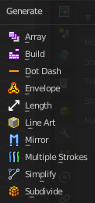
Some of the modifiers are just available for specific object types.
Left grease pencil object, right a mesh object.

Array
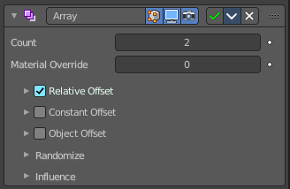
The Array modifier creates an array of copies of the base object. Each copy can offset from the previous one in any of a number of possible ways. Vertices in adjacent copies can be merged if they are nearby, allowing smooth Subdivision Surface frameworks to be generated.
This modifier can be useful when combined with tillable meshes for quickly developing large scenes. It is also useful for creating complex repetitive shapes.
Multiple Array modifiers may be active for an object at the same time. This allows to create complex three-dimensional constructs.
Hint for Offset Calculation. The transformation applied from one copy to the next is calculated as the sum of the three different components (Relative, Constant and Object), each of which can be enabled/disabled independently of the others. This allows, for example, a relative offset of (1.0, 0.0, 0.0) and a constant offset of (0.1, 0.0, 0.0), giving an array of objects neatly spaced along the X axis with a constant 0.1 unit between them, whatever the original object’s size.

Count
Number of Items

Material Override
Index of the material used for generated strokes. A value of 0 uses the original material.

Relative Offset subpanel

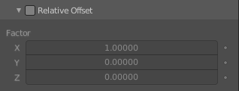
Factor X/Y/Z
Adds a translation equal to the object’s bounding box size along each axis to the offset, multiplied by a scaling factor. X, Y and Z scaling factors can be specified.

Constant Offset subpanel

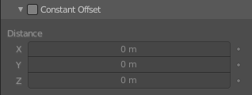
Distance X/Y/Z
Adds a constant translation component to the duplicate object’s offset. X, Y and Z constant components can be specified.

Object Offset subpanel
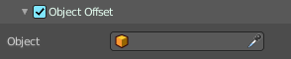
Adds a transformation taken from a chosen object relative to the current object to the offset.

Object
Choose an object.

Randomize
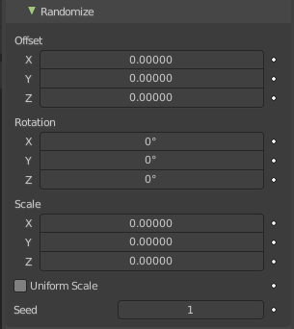
Randomize the transform values.

Offset
Randomize the offset values.

Rotation
Randomize the rotation values.

Scale
Randomize the scale values.

Uniform Scale
Use uniform scaling.

Seed
The random seed value.

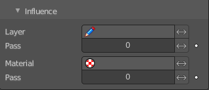
Influence subpanel

Layer
Restricts the effect only to one layer or to any layers that share the same pass index. Click to pick the layer that you want to use.

Inverse Layers
Inverts the influence.

Pass
The layer pass index.

Inverse Pass
Inverts the influence.

Material
Restricts the effect only to material that share the same material or pass index. Click to pick the material that you want to use.

Invert Materials
Inverts the influence.

Pass
The material pass index.

Inverse Pass
Inverts the influence.

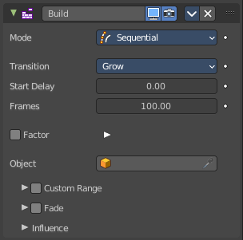
Build
The Build modifier lets the strokes of the grease pencil object appear or disappear over time when you play the animation.

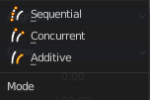
Mode
How many strokes are animated at the same time.

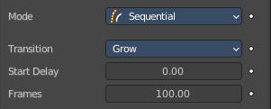
Sequential
Strokes appear or disappear one after the other.

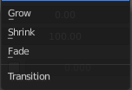
Transition
How the strokes are animated. The items should be self explaining.

Start delay
Number of frames after each GP keyframe before the modifier has any effect.

Frames
Maximum number of frames that the build effect can run.

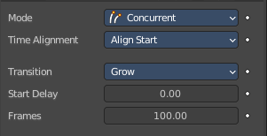
Concurrent
All strokes appear or disappear at once.

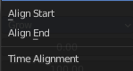
Time Alignment
When strokes should start to appear or disappear.

Align Start
All strokes appears at the same time.

Disappear
All strokes disappears at the same time.

Transition
How the strokes are animated. The items should be self explaining.

Start delay
Number of frames after each GP keyframe before the modifier has any effect.

Frames
Maximum number of frames that the build effect can run.

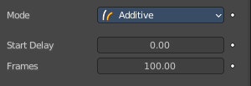
Additive
Builds only new strokes. Assumes additive painting.

Start delay
Number of frames after each GP keyframe before the modifier has any effect.

Frames
Maximum number of frames that the build effect can run.

Factor
Use a factor instead of fixed frames. Turning on Use Factor will turn off Start Delay and Frames.

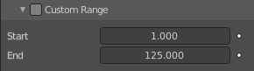
Custom Range
Only modify strokes that lies in the specified time frame.

Start
The first frame of the range.

End
The last frame of the range.

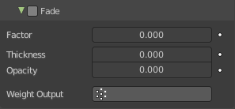
Fade subpanel
Fade out strokes instead of cutting them off.

Factor
The factor for how much the stroke is fading out.

Thickness
How much strength fading applies on top of stroke thickness.

Opacity
How much strength fading applies on top of stroke opacity.

Weight Output
Limit the fade to a vertex group.

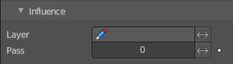
Influence subpanel

Layer
Restricts the effect only to one layer or to any layers that share the same pass index. Click to pick the layer that you want to use.

Inverse Layers
Inverts the influence.

Pass
The layer pass index.

Inverse Pass
Inverts the influence.

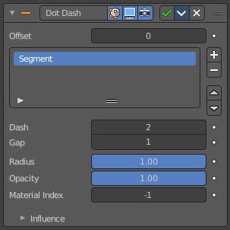
Dot Dash
Turns a grease pencil stroke into a dotted line.

Offset
The offset into each stroke before the dot creation starts.

Segment list
Manage the single segments of the dotted dash. Segments gets repeated as they appear in the list. Means when you just have one segment in the list, then this shape will be repeated. When you have two, then the first will be displayed, then the second, then the first, and so on. Every segment can have its own settings. Which are managed below.

Add Segment
Add a new dash segment.

Remove Segment
Remove the dash segment.

Move Dash Segment up or down
Moves the selected dash segment up or down in the list.

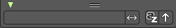
Search element
By clicking at the triangle button you reveal a search field with which you can search through the list.

Edit Box
Type in the search term and hit enter.

Invert
Inverts the search term.

Sort by name
Sorts the list alphabetically.

Reverse
Inverts the list.

Dash
The number of points (vertices) from the orignal stroke to include in this segment.

Gap
The number of points (vertices) skipped after this segment.

Radius
The radius of the segment. Maximum is 1 of the original stroke.

Opacity
The visibility of this segment.

Material Index
What material to use.

Influence subpanel

Layer
Restricts the effect only to one layer or to any layers that share the same pass index. Click to pick the layer that you want to use.

Inverse Layers
Inverts the influence.

Pass
The layer pass index.

Inverse Pass
Inverts the influence.

Material
Restricts the effect only to material that share the same material or pass index. Click to pick the material that you want to use.

Invert Materials
Inverts the influence.

Pass
The material pass index.

Inverse Pass
Inverts the influence.

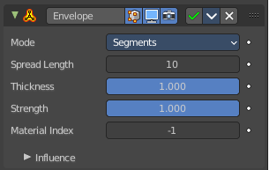
Envelope
Generates a envelope shape that connects all points in this envelope.

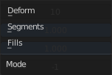
Mode

Deform
Deform the stoke to best match the envelope shape.

Segments
Add segments to create the envelope. Keep the original stroke.

Fills
Add Fill segments to create the envelope. This method does not keep the original stroke.

Spread Length
The number of points to skip to create straight segments.

Thickness
Thickness multiplier for the thickness of the new stroke.

Strength
Strength multiplier for the strength of the new stroke.

Material Index
The material index of the material that is used.

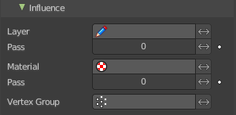
Influence subpanel

Layer
Restricts the effect only to one layer or to any layers that share the same pass index. Click to pick the layer that you want to use.

Inverse Layers
Inverts the influence.

Pass
The layer pass index.

Inverse Pass
Inverts the influence.

Material
Restricts the effect only to material that share the same material or pass index. Click to pick the material that you want to use.

Invert Materials
Inverts the influence.

Pass
The material pass index.

Inverse Pass
Inverts the influence.

Vertex Group
Assign a vertex group to modulate the deform.

Inverse Pass
Inverts the influence.

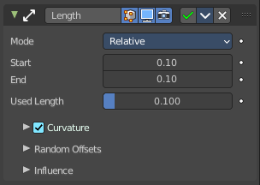
Length
The Length Modifier extends or shortens the original strokes length.

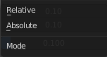
Mode
Defines the mode to use for the length calculation. Relative to the length of the grease pencil stroke, or absolute in geometry space.

Factor Start/End
Length difference for each stroke.

Used Length
What position of the stroke is used for the calculation of the extension.

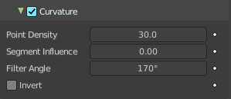
Curvature subpanel
Follow the curvature of the stroke.

Point Density
Multiplied by Start/End for the total added point count.

Segment Influence
How much the length of the individual segments should influence the final computed curvature.

Filter Angle
Ignore points of the stroke that derivate from their neighbours by more than this angle.

Invert
Invert the curvature of the stroke's extension.

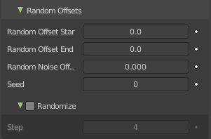
Random Offset subpanel
Randomization for the start / end lengths.

Random offset Start
Size of random length added to the start of each stroke.

Random offset End
Size of random length added to the end of each stroke.

Random Noise Offset
Smoothly offset the random value of each stroke.

Seed
The random seed value.

Randomize subpanel
Use random values over time.

Step
Number of frames before recalculate random values again.

Influence subpanel

Layer
Restricts the effect only to one layer or to any layers that share the same pass index. Click to pick the layer that you want to use.

Inverse Layers
Inverts the influence.

Pass
The layer pass index.

Inverse Pass
Inverts the influence.

Material
Restricts the effect only to material that share the same material or pass index. Click to pick the material that you want to use.

Invert Materials
Inverts the influence.

Pass
The material pass index.

Inverse Pass
Inverts the influence.

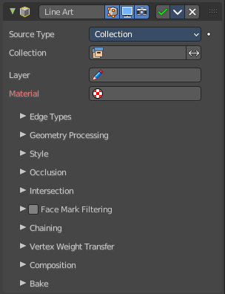
Line Art
The Line Art modifier generates stylized line art from the scene or selected source collection or objects.
Note that due to lack of global cache at the moment, each Line Art modifier will run the entire occlusion calculation for itself. So if you have multiple line art modifiers to select different parts of the scene (to apply different styles, etc.), the evaluation will take much longer. There are plans to remedy this in the future, but this is a known limitation for now.

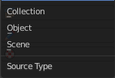
Source Type
What type of geometry source should line art be generated from.

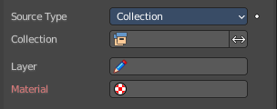
Collection

Collection
The collection where you want to apply the line art to.

Invert
Inverts the selection of collections.

Layer
Grease Pencil layer that is assigned to the generated strokes.

Material
Grease pencil material assigned to the generated strokes.

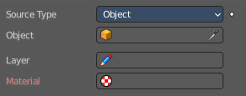
Object

Object
The object where you want to apply the line art to.

Layer
Grease Pencil layer that is assigned to the generated strokes.

Material
Grease pencil material assigned to the generated strokes.

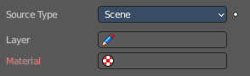
Scene
Applies the line art grease pencil strokes to the whole scene.

Layer
Grease Pencil layer that is assigned to the generated strokes.

Material
Grease pencil material assigned to the generated strokes.

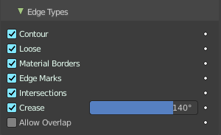
Edge types subpanel
Which kind of edges to influence. The names from contour to intersections should be pretty self explaining.

Crease
Influence crease edges. The angle what edges are treaten as creases can be adjusted in the edit box.

Allow Overlap
Allow an edge to have multiple overlapping types.

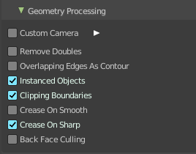
Geometry Processing subpanel


Custom Camera
Allows to pick a different camera than the active scene camera for line art rendering.

Remove Doubles
Perform an “merge by distance” operation when loading geometry into Line Art. The threshold of this operation is internally set to a value that is optimal for Line Art algorithm precision.

Overlapping Edges as Contour
This option allows overlapping edges (e.g. from an edge split modifier or imported geometry where two edges occupy the exact same space) to be drawn as contour. Enabling this option will slow down the calculation slightly but it will handle edge overlapping cases without erroneous occlusion results.

Instanced Objects
This option enables particles and other instanced objects to be loaded for line art calculation. There will be performance impact when there are a large amount of instanced objects in the scene.

Clipping Boundaries
When enabled, line art will generate clipping lines as contour type at the place where near or far clipping planes cut the model. Otherwise there will be no lines.

Crease on Smooth
Allow crease edges to show inside smooth surfaces.

Crease on Sharp
Allow crease to show on sharp edges.

Back Face Culling
Remove all backfaces to speed up calculation.

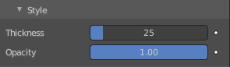
Style Subpanel

Thickness
The strokes generated by line art are given this thickness.

Opacity
The strokes generated by line art are given this Opacity.

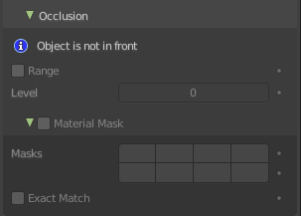
Occlusion Subpanel

Range
If enabled, the modifier will select lines that have an occlusion level between start and end values.
If not enabled just a single Level value slider shows.

Material Mask
Use material masks to filter out occluded strokes. You need to have a range level higher than 0.

Masks
Choose up to eight mask bits for the masking.

Exact match
Require matching all material masks instead of just one.

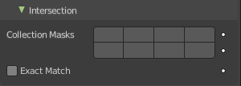
Intersection subpanel

Collection Masks
Choose up to eight mask bits for masking.

Exact match
Require matching all intersections instead of just one.

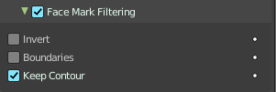
Face Mask Filtering subpanel
Filter Feature Lines using Freestlye Face Masks.

Invert
Invert face mask filtering.

Boundaries
Filter feature lines based on face mask boundaries.

Keep Contour
Preserve contour lines while filtering.

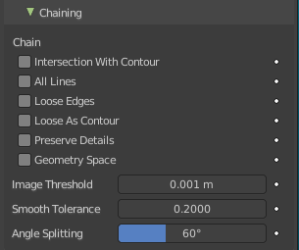
Chain

Intersection with Contour
Allows intersection lines to be chained together with contour lines.

All Lines
Enabling this option will cause all lines to have the type of contour and to be chained together.

Loose Edges
Allow loose edges to be chained together.

Loose As Contour
Loose edges will have contour type.

Preserve Details
Keep the zig-zag noise in initial chanining.

Geometry Space
Use Geometry distance for chaining instead of image space.

Image Threshold
Segments with an image distance smaller than this value will be chained together.

Smooth tolerance
Strength of smoothing applied on jagged chains.

Angle Splitting
The angle in screen space below which a stroke is split into two.

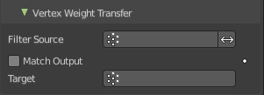
Vertex Weight Transfer subpanel

Filter Source
If source mesh has vertex groups whose name starts with this string, then the vertex weight info will be transferred into weight groups in Grease Pencil strokes.

Invert Vertex Group
Inverts the selection.

Match Output
Transfer the filtered object vertex weights into Grease Pencil weight groups with the same names as the filtered ones.

Target
If Match Output is off, then a target vertex group has to be specified. If there are multiple weight groups copied into target, then the highest weight value is copied into it.

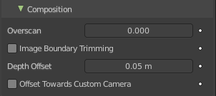
Composition

Overscan
A margin to prevent an abrupt end of the stroke at the edge of the image.

Image boundary trimming
Trim all edges right at the boundary of image (including overscan region)

Depth Offset
Move strokes slightly towards the camera to avoid clipping.

Towards custom camera
Offset strokes towards selected camera instead of the active camera.

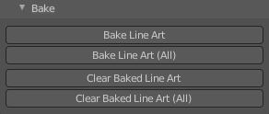
Bake subpanel

Bake Line Art / Bake Line Art (All)
Bakes Line Art strokes for active Grease Pencil object within the start, end frame range in scene.
Bake Line Art (All) bakes all Grease Pencil objects that contains at least one Line Art modifier. After baking, baked Line Art modifier will be deactivated automatically.

Clear Baked Line Art / Clear Baked Line Art ( All)
Clears baked line art frames within the scene frame range for active Grease Pencil object.
Clear Baked Line Art (All) applies the same operation for all Grease Pencil objects that contains at least one Line Art modifier.

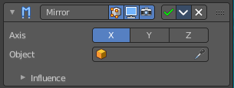
Mirror
The Mirror modifier for the Grease Pencil Object works in Object mode. It mirrors the object along its local X, Y and/or Z axes, across the Object Origin. It can also use another object as the mirror center, then use that object’s local axes instead of its own.

Object
Define an object to mirror at its origin instead of mirroring along the grease pencil origin.
You can animate it to move the mirror axis.

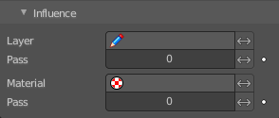
Influence

Layer
Restricts the effect only to one layer or to any layers that share the same pass index. Click to pick the layer that you want to use.

Invert
Inverts the influence.

Pass
The layer pass index.

Invert
Inverts the influence.

Material
Restricts the effect only to material that share the same material or pass index. Click to pick the material that you want to use.

Invert
Inverts the influence.

Pass
The material pass index.

Invert
Inverts the influence.

Multiple Strokes
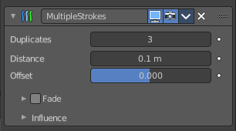
Adds multiple parallel copies of the stroke around the original stroke.

Duplicates
The number of additional strokes.

Distance
Distance between the original and the duplicate strokes.

Offset
Control the offset position (inner or outer) for duplicate strokes.

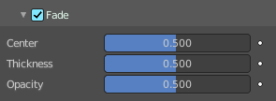
Fade
Fade out duplicate strokes, using their opacity or thickness.

Center
Control the initial position for the fading.

Thickness
Fade influence on strokes thickness.

Opacity
Fade influence on strokes opacity.

Influence

Layer
Restricts the effect only to one layer or to any layers that share the same pass index. Click to pick the layer that you want to use.

Invert
Inverts the influence.

Pass
The layer pass index.

Invert
Inverts the influence.

Material
Restricts the effect only to material that share the same material or pass index. Click to pick the material that you want to use.

Invert
Inverts the influence.

Pass
The material pass index.

Invert
Inverts the influence.

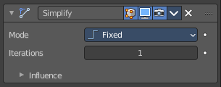
Simplify
The Simplify modifier allows you to reduce the amount of points in the strokes. It tries to reduce points while maintaining the lines shape.

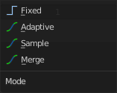
Mode
How to reduce points in the strokes.

Fixed
Deletes alternated points in the strokes, except the start and end points.

Adaptive
Uses the RDP algorithm (Ramer-Douglas-Peucker algorithm) for points deletion. The algorithm try to obtain a similar line shape with fewer points.

Sample
Recreates the stroke geometry with a predefined length between points.

Merge
Simplifies the strokes by merging points that are closer than a specified distance to each other.

Iterations
Number of times to repeat the procedure.

Influence

Layer
Restricts the effect only to one layer or to any layers that share the same pass index. Click to pick the layer that you want to use.

Invert
Inverts the influence.

Pass
The layer pass index.

Invert
Inverts the influence.

Material
Restricts the effect only to material that share the same material or pass index. Click to pick the material that you want to use.

Invert
Inverts the influence.

Pass
The material pass index.

Invert
Inverts the influence.

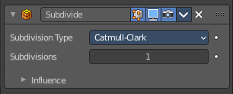
Subdivide
The Subdivide modifier subdivide the strokes by inserting points between other points to the lines.

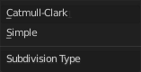
Subdivision Type

Catmull-Clark
Subdivides and smooths the surfaces.

Simple
Only subdivides the surfaces, without any smoothing.

Subdivisions
Number of subdivisions.

Influence

Layer
Restricts the effect only to one layer or to any layers that share the same pass index. Click to pick the layer that you want to use.

Invert
Inverts the influence.

Pass
The layer pass index.

Invert
Inverts the influence.

Material
Restricts the effect only to material that share the same material or pass index. Click to pick the material that you want to use.

Invert
Inverts the influence.

Pass
The material pass index.

Invert
Inverts the influence.

